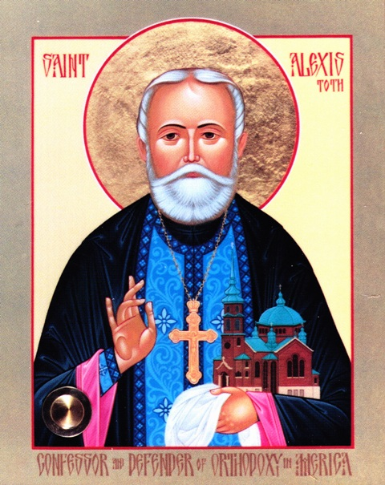
~ 2012 Annual St Alexis (Toth) Lecture ~
St Mary's Orthodox Cathedral
Sunday, May 6 at 7: 15 pm

Archpriest John Jillions, Chancellor
Orthodox Church in America
ST ALEXIS:
COURAGE, CONFIDENCE AND THE CROSS
Reception to follow

An annual series sponsored by the Borris-Hansen Committee at St Mary's Cathedral
1701 Fifth Street NE Minneapolis MN 55413 (612) 781-7667
www.stmarysoca.org

